**Feature selection table:**

|  |  |  |  |  |  |  |  |  |  |  |
| --- | --- | --- | --- | --- | --- | --- | --- | --- | --- | --- |
| **Bio inspired algorithms** | **CM1** | | **JM1** | | **KC1** | | **KC2** | | **PC1** | |
| **Before** | **After** | **Before** | **After** | **Before** | **After** | **Before** | **After** | **Before** | **After** |
| Sparrow Search Algorithm | 21 | 17 | 21 | Error | 21 | 18 | 9 | 7 | 9 | 8 |
| Squirrel Search Algorithm | 21 | 16 | 21 | 15 | 21 | 16 | 9 | 6 | 9 | 8 |
| Bat Search Algorithm | 21 | 12 | Error (resolving) | Error (resolving) | 21 | 9 | Error (resolving) | Error (resolving) | 9 | 4 |

**Sparrow Search Algorithm:**

Features before and after selection for CM1 dataset:

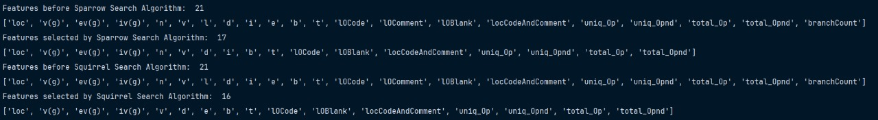

JM1 dataset:

KC1 dataset:



KC2 dataset:

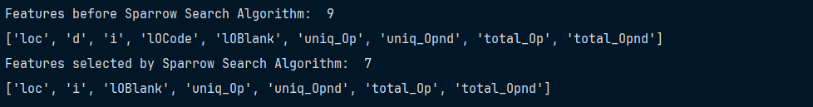

PC1 dataset:

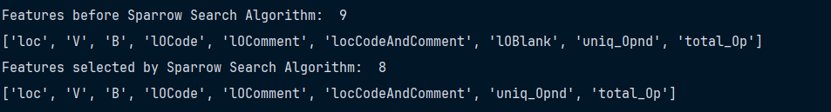

**Squirrel Search Algorithm:**

Features before and after selection for CM1 dataset:



JM1 dataset:



KC1 dataset:



KC2 dataset:

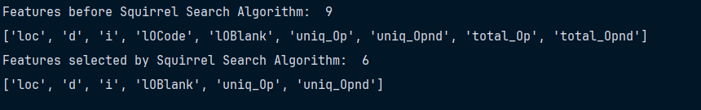

PC1 dataset:

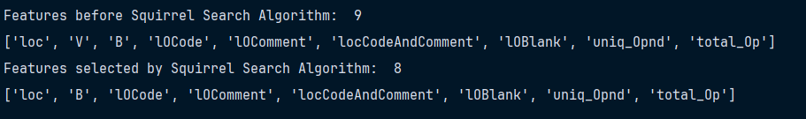

**Bat Search Algorithm (threshold is set at 0.7):**

Features after selection for CM1 dataset:



KC1 dataset:





PC1 dataset:



